关于上报IMO2010年海上搜救
特别勇敢奖候选人提名材料的报告

中国海上搜救中心：
按照《关于报送国际海事组织2010年海上搜救特别勇敢奖候选人提名材料的通知》和IMO第2934号通函要求，我中心对各市海上搜救中心和相关单位、部门上报的材料进行了严格的评选。经审查，推荐“浙平渔2325”为IMO2010年海上搜救特别勇敢奖候选人。

附件： “浙平渔2325”提名材料（中英文材料、IMO第2934号通函附件3）

二〇一〇年三月十五日
附件
“浙平渔2325”报送国际海事组织
2010年海上搜救特别勇敢后选人提名材料
--“浙平渔2325”成功救助“东海818”轮4名落水船员

2009年9月29日1330时许，福建省平潭县轮船公司所属的“东海818”轮从上海驶往汕头途经温州洞头沿海虎头屿附近水域因受风浪影响沉没，船上7名船员全部落水，急需救助。
接到温州市海上搜救中心发布的船舶遇险信息后，正在附近作业的“浙平渔2325”立即停止作业，果断决定加速驶往事发水域参与搜救。据温州气象台气象预报和事发水域船舶反馈，当时事发水域附近东北风8-9级，浪高3-4米，暴雨，能见度不到1海里，如此恶劣的气象条件下，7名落水人员的生命受到了严重威胁，情况万分紧急。遇险人员是否能够生还取决于救助行动是否能够及时开展，取决于救助船艇到达现场的时间。
“浙平渔2325”驶往现场途中，海上风力持续加强，阵风达到10级，暴雨如注，能见度下降到只有500米左右，“浙平渔2325”船长发挥高超的操纵技能，驾驶渔船在起伏的波浪中继续前进，如同惊天骇浪中自由穿梭的海豚。经过1个多小时的艰难航行，“浙平渔2325”于1600时驶抵事发水域。船长立即报告温州市海上搜救中心，随即在中心的技术指导下开展搜寻工作。1620时，“浙平渔2325”成功在虎头屿西南方面发现载有4名遇险船员的救生筏，当时现场风大浪急，救生筏在风浪中上下颠簸，“浙平渔2325”自身受风浪影响也出现大幅度的摇晃，救助过程中稍有不慎，救生筏将可能被渔船撞翻。面对紧急时刻，“浙平渔2325”船长抛开一切杂念，充分利用车舵和娴熟的驾驶技术，成功靠近救生筏，并将4名遇险船员全部安全转移至渔船上；1643时，“浙平渔2325”将救起的4名船员转移至前来接应的政府公务船上，继续执行搜寻任务，直至7名落水人员全部获救后方驶离现场继续进行渔业生产。
刚刚救起的落水船员
面对风高浪急的恶劣气象海况，“浙平渔2325”全体船员充分发扬国际人道主义精神，迎难而上，在最短的时间内赶赴事发现场并取得非常好的救助效果，展现了中国海上搜救力量的风采和情操。事后，“浙平渔2325”风浪中勇敢救助4条人命被新闻媒体报道，得到了社会舆论的高度好评。

Reporting Materials of Fishing Boat “ZHEPINGYU2325”
Submitted to IMO
for
Candidate for 2010 IMO Award for Exceptional Bravery at Sea
-- Fishing Boat “ZHEPINGYU2325”’s successful rescue of 4 crews of the sank vessel “DONGHAI818”
About 1330 hours of September 29th 2009, The vessel "DONGHAI818" belonged to PINGTAN shipping company, Fujian Province, sailing from Shanghai to Shantou, when sailing through the coastal waters around Wenzhou DONGTOU HUTOU island, sank due to storms, seven crews overboard and need immediately assistance。
When receiving the distress alert from Wenzhou Maritime Rescue Coordination Centre, The fishing ship "ZHEPINGYU2325" immediately stopped operations and sailed to the position directed by MRCC .According to the report of meteorological station and ships in vicinity of distress position, there was north-easterly 8-9 level, wave height 3-4 meters, heavy rain, visibility less than 1 nautical mile in the vicinity waters.
Seven crews over boat had been seriously threatened, the situation is extremely urgent. Whether the crews in water could be survived, depending on the actions could timely carry on, depending on the time of rescue boat arrived at the scene.
On the way to the scene, wind sustained increasing, gusts reached 10 levels, heavy rain, visibility dropped to only 500 meters, the captain of "ZHEPINGYU2325" gave play to excellent manipulation skills, derived the boat to move forward in the undulating waves as a free shuttle dolphin.
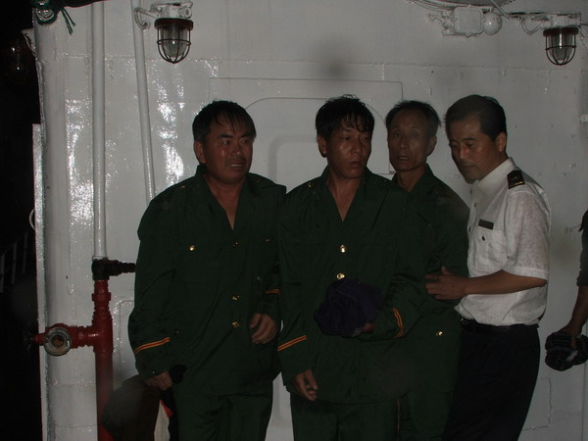

The crews saved

After a difficult voyage more than one hour,"ZHEPINGYU2325" reached the scene at 1600 , reported to MRCC and carried out searching under the technical guidance of MRCC. About 1620,"ZHEPINGYU2325" found 4 crews in life raft on the southwest area of HUTOU Island. Life raft rocked up and down in rhythm with the wave, "ZHEPINGYU2325" also rolled very much in heavy wave. If careless, life raft would be knocked down by fishing ship. In times of crisis, captain of "ZHEPINGYU2325" put aside distracting thoughts and gave play to the rudder and driving skills. The fishing ship successfully alongsided the life raft and saved 4 crews. At 1643, transferred 4 crews to the government SAR facilities and continued to search until all over board crews were saved. Then left the scene continue it’s operation.
Facing of bad conditions with storm and waves ,All crews of "ZHEPINGYU2325" carried forward the spirit of international humanitarian, went to the scene in the shortest time and got very good effect, demonstrated the style and sentiment of China's maritime search and rescue force. After the accident, Media also made detailed reports about this rescue operation.

ANNEX 3
DESCRIPTION OF CIRCUMSTANCES AND EVENTS
In accordance with paragraph of the Guidelines for the IMO Award for Exceptional Bravery at Sea, the candidature of ……….[nominee] ZHE PING YU 2325……………is supported by the following description of the circumstances and events giving rise to the nomination. It is noted that not all of the information requested below may be available; nonetheless, as much information as possible should be provided to enable the panel of judges to make an informed decision.
1 Location of incident (latitude/longitude or distance/bearing from known geographic point of reference):
_____________________27°52′.408N/121°13′.384E _______________________________
- On scene weather (wind/sea state/precipitation/temperature):
__ north-easterly 8-9 level, wave height 3-4 meters, heavy rain, visibility less than 1 nautical miles ________ _____________________________
3 Details of incident (please note that the intent of the Award is to recognize actions in response to a specific incident, rather than multiple incidents that may have occurred during the period of time under consideration):
- Nature of distress (sinking, fire, collision, etc):
___________________________Sinking______________________________________________
- Date/time of incident:
__________________About 1330_Septemper 29st,2009__ __________________
- Name/description of vessel (or person)in distress:
____________________M/V “DONG HAI 818”________________________________________
- Total number of lives at risk:
_____________________________Seven______________________________________________
- Number of lives saved:
_____________________________ Seven _____________________________________________
- Name of Maritime Rescue Coordination Centre (MRCC) (or other shore-based organization) involved that may have relevant records of incident:
__ ____Wenzhou MRCC ______
4 Details of individual/group nominated:
- Ship/unit to which nominee was attached at time of rescue:
________________Fishing boat “zhe ping yu 2325”___________________________________
- Parent company/ organization:
___________ _________Nil_______________________________________________
- Nominee’s name, nationality and position/ assignment on board:
______ Fishing boat _“zhe ping yu 2325”,China_, fishing boat__________________________
- Nominee’s role in rescue operation:
Rescuer __________ ____________
5 Is nominee a SAR professional (or trained and/or experienced in Search and/or Rescue beyond fundamental level required of their regular non SAR related position):

___ ________Experienced in search ______
- Exceptional circumstance where nominee clearly placed his/her own life at risk (please include degree of risk (severe/moderate/low):
Severe
- If incident involved attempting to mitigate damage to the marine environment, please describe consequences to the environment if nominee’s action was not taken:
Nil ______
- Any other information supporting the nomination (please provide all relevant details of the conditions pertaining to the reported act of bravery):
Nil ______

